Paper Title
Masters of Engineering  Information Technology  A S M Saiem Solimullah  Matriculation Number:  a.solimullah@stud.fra-uas.de | Masters of Engineering  Information Technology  A S M Saiem Solimullah  Matriculation Number:  a.solimullah@stud.fra-uas.de

Abstract— The ultrasonic sensors which use high frequencies sound wave can be used to identify people or objects along with measuring distance. This sensor uses sound waves that are emitted, bounce off surrounding objects, and return to the sensor, which uses the time it takes for the sound waves to return to determine the distance. Red Pitaya is an open-source, multifunctional tool designed for education, research, and prototyping. Its web-based interface and compatibility with programming languages make it accessible for beginners and professionals alike.
Keywords—ADC, FFT, PSD, MLP & SVM

Introduction (Heading 1)
Technology these days is doing some amazing things, especially when it comes to figuring out if someone’s nearby or not, without requiring camera sensors or any kind of too expensive devices. This paper dives into the common feature-based work of ultrasound, which uses sound waves that are too high-pitched for humans to hear. Detection can be found by analyzing more smart systems when a person is nearby without needing to touch or watch them closely. Consider an IOT based, smart home that automatically adjusts the lights when someone walks in, or a robot that moves around without bumping into anyone, or even a safety system that alerts others if someone’s in a risky area, like near heavy machinery. Ultrasound is perfect for these kinds of applications because of its discreet and unwanted video recordings. Also, it works well in all kinds of environments whether it’s dark or messy. In medical research, using pulse ultrasound measurement different thing can be diagnosed like blood pressure [1]. This project is based on the FIUS Sonar Sensor device outputs, a device that measures these sound waves to detect different distance object or movement of the object. The distance (d_{FIUS}) to an object can be determined using the inbuilt feature or using machine learning techniques. For distance measuring feature, FIUS uses the time takes for the ultrasonic pulse to return. In this project the object type was person and static object(soft/hard). The FIUS is mounted about 40-50 cm above the ground, keeping an eye out for movement directly across its path. It’s already decent at measuring distances, but this analysis aims to make it even better particularly at distinguishing between a person and other static object, like a chair or a box. The main goal of this project is to measure the FIUS’s ability to detect the object and measure the distance of that object accurately and reliably. The steps include collecting and labeling ultrasonic echo data for different distance of the object, developing algorithms for echo detection, after measuring the distance apply supervised machine learning algorithms for object type detection based on the collected data features. And finally, implementing real-time sensor output based on detection results.

Litarature review
Before you begin to format your paper, first write and save the content as a separate text file. Complete all content and organizational editing before formatting. Please note sections A-D below for more information on proofreading, spelling and grammar.

Theoretical Background
Before you begin to format your paper, first write and In this project, we have used several components to assess the reliability and improve an object detecting sensor system. Here in this section, those element descriptions will be given over the necessary hardware, the programming language, and the machine learning technique that have been employed to create the model.

Red Pitaya Based FIUS sonar sensor:
Red pitaya is a stem lab board that can measure analog and digital signal. This has the ADC features which enables it to convert the analog signal into digital signal and vice versa. Red pitaya’s open-source hardware and software can be coupled with an easy-to-use web interface, which enhance data visualization and remote control. The sensor used for this project to measure the horizontal and perpendicular data has 16 general input and output physical ports along with an RJ45 socket connector for the Ethernet and an USB port. The red pitaya sensor can measure high range frequency signal. For this project, only 30 KHz to 50 KHz signal taken into account. 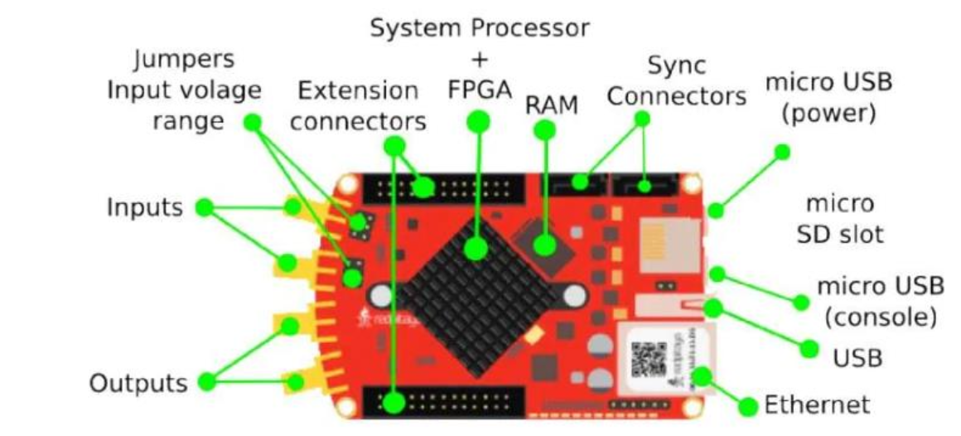
Figure 1: Red pitaya steam board configuration
The fully integrated ultrasonic sensor (FIUS) is a compact, high performance ultrasonic signal sensing device. Ultrasonic sensor basically uses ultrasonic waves to calculate the distance to an object. This device is commonly used in robotics, automation and proximity detection applications. This device worked based on the echolocation of the signal. The sensor emits high frequency signals and then receive the same signal, which then calculate the distance of the sensor received signal using the time to flight formula.
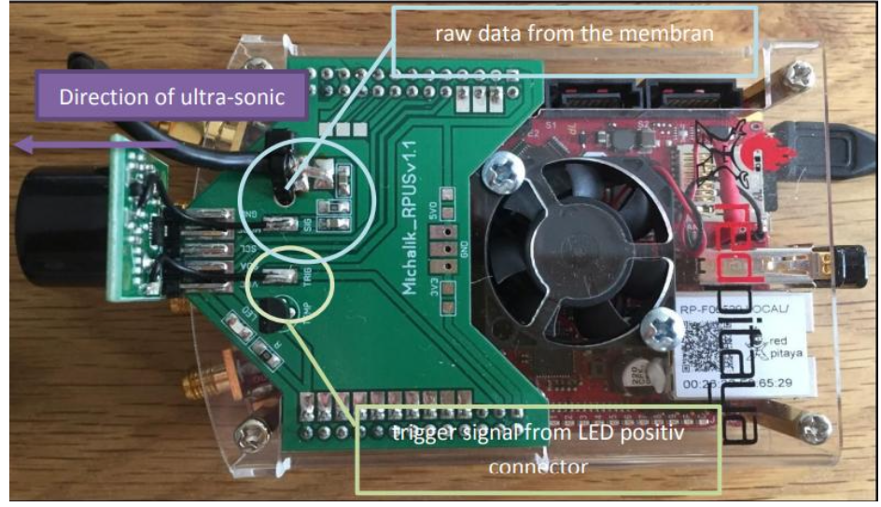
Figure 2: Red pitaya board’s hardware and sensors
After calculating the signal data, first eco can be easily detected for the object and then the distance of that object can be measured.

Eco Detection
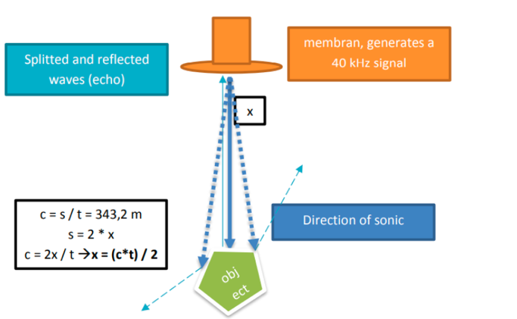
Eco detection is an important process to find the distance from the ultrasonic sonar sensor. It identifies the reflected sound waves that returns after hitting an object. From this reflected wave we can find the approximate distance of the object. Using this first eco detection process we have identified the distance of the object in our project.

.”

Fast Fourier Transform:
FFT transform a signal from time domain to frequency domain which allows the analysis of the frequency component of the ultrasonic sound waves. We have applied autocorrelation function to the raw ADC signal which then transformed with FFT after applying a window to the data portion of the signal. This gives an output of power spectral density which helped to classify the signal later applied on the machine learning model.

ADC Data
The data we have found from the ultrasonic sensor is analog raw data. ADC samples this high frequency rate data and can convert it into digital form through FFT. These digital data frames then can be analyzed or classified using algorithm like MLP or SVM.

Multilayer Perceptron (MLP) Classifier
MLP is a type of feed forward neural network consisting of inputs, hidden and output layers. It is trained via backpropagation algorithm and useful for complex pattern learning, signal analysis and data classification. We have used MLP classifier for finding object type from different pattern of the data. We have used two different types of MLP classifier for finding the object type and distance from the raw signal data.

Confusion Matrix
A confusion matrix is a table that shows us how well a classification model is performing is called a confusion matrix. It compares the predicted results of the model with the actual results. In our project we have analyzed the result of the performed model using this confusion matrix. This confusion matrix consists of four different elements as True Positive, True Negative, False Positive and False Negative.
Also using this confusion matrix, we have analyzed the result of different matrices.
- Accuracy: How many predictions were correct in the dataset.
- Precision: How many predictions was accurate can be found through this matrix.
- Recall: How many true results we catches using the models.
- F1 Score: It defines a balance between precision and recall.

Methodology
FIUS sensor which used in this project mounted with the red pitaya at a height of 40-50cm above from the ground for measuring the distance of the object along with the object type. It is based on a field-programmable gate array (FPGA) and a dual-core ARM Cortex-A9 processor, which allows real-time signal processing and control.

Data Acquisition
In order to detect the object type, two different types of object data have been taken from the sensor in different distance. In dataset 1, 2 and 3, Almost 9000 data have been collected every time for several distance with different objects. The object type was person and a static box. This whole experiment was monitored in the FIUS Ultrasonic Sensor UI interfaces. For different distance reading 1000 signal data has been observed. For individual time series data, 50000 data point have been found from the time series signal along with 17 header information. Also, before started to take the data measurement of the sensor for the object, different distance has been marked for manual measurement of the distance data.

Darta Preprocessing
In order to find the information and features from the ADC signal found from the sensor, data need to be preprocessed. Later those preprocessed data were feeded to the machine learning model for better accuracy.

Data Labelling: After collecting the data from the sensor, raw data has been added with two different level columns as “Distance” and “Object”. On the distance column, the measurement of manual distance has been added and on the object column, object types of the data have been defined. For visualsing the proper data in the dataframe we added header title in the dataset which has been used in the s

Removing Header: The data found from the ultrasonic sensor has 50017 columns, in which 17 column is header information and 50000 column is time series data information. For finding the valid signal those headers were removed when preprocessed the signal data.
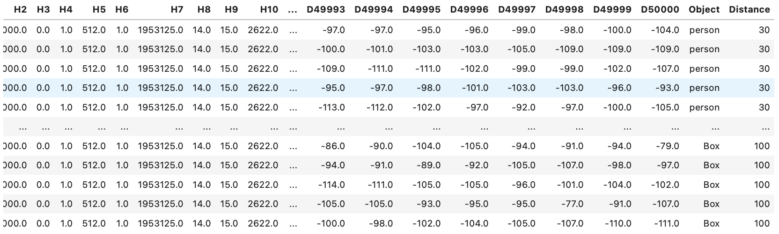

First Eco Detection: For finding the distance of the object from the sensor data, first we need to find the first echo of the signal. After finding the first echo of the signal distance of the data can be calculated and these calculated data has been later stored in the data frame as a separate column leveled as “First Echo Index”.

ACF and Windowed Signal: Autocorrelation function and window has been applied to the data to find the power spectral density of the signal. For finding this power spectral density, sampling frequency assumed to be 195317 Hz and the applied window size was 300 on the signal data. This PSD calculation has been done using welch method which is an inbuilt method for finding the PSD in the python. These PSD features then feed to the model for train and testing the data to find the object type and distance from the signal.

MLP Classifier & SVM

The data we have found from the ultrasonic sensor is analog raw data. ADC samples this high frequency rate data and can convert it into digital form through FFT. These digital data frames then can be analyzed or classified using algorithm like MLP or SVM.

Acknowledgment (Heading 5)
The preferred spelling of the word “acknowledgment” in America is without an “e” after the “g”. Avoid the stilted expression “one of us (R. B. G.) thanks ...”. Instead, try “R. B. G. thanks...”. Put sponsor acknowledgments in the unnumbered footnote on the first page.

References
The template will number citations consecutively within brackets [1]. The sentence punctuation follows the bracket [2]. Refer simply to the reference number, as in [3]—do not use “Ref. [3]” or “reference [3]” except at the beginning of a sentence: “Reference [3] was the first ...”
Number footnotes separately in superscripts. Place the actual footnote at the bottom of the column in which it was cited. Do not put footnotes in the abstract or reference list. Use letters for table footnotes.
Unless there are six authors or more give all authors’ names; do not use “et al.”. Papers that have not been published, even if they have been submitted for publication, should be cited as “unpublished” [4]. Papers that have been accepted for publication should be cited as “in press” [5]. Capitalize only the first word in a paper title, except for proper nouns and element symbols.
For papers published in translation journals, please give the English citation first, followed by the original foreign-language citation [6].

- G. Eason, B. Noble, and I. N. Sneddon, “On certain integrals of Lipschitz-Hankel type involving products of Bessel functions,” Phil. Trans. Roy. Soc. London, vol. A247, pp. 529–551, April 1955. (references)
- J. Clerk Maxwell, A Treatise on Electricity and Magnetism, 3rd ed., vol. 2. Oxford: Clarendon, 1892, pp.68–73.
- I. S. Jacobs and C. P. Bean, “Fine particles, thin films and exchange anisotropy,” in Magnetism, vol. III, G. T. Rado and H. Suhl, Eds. New York: Academic, 1963, pp. 271–350.
- K. Elissa, “Title of paper if known,” unpublished.
- R. Nicole, “Title of paper with only first word capitalized,” J. Name Stand. Abbrev., in press.
- Y. Yorozu, M. Hirano, K. Oka, and Y. Tagawa, “Electron spectroscopy studies on magneto-optical media and plastic substrate interface,” IEEE Transl. J. Magn. Japan, vol. 2, pp. 740–741, August 1987 [Digests 9th Annual Conf. Magnetics Japan, p. 301, 1982].
- M. Young, The Technical Writer’s Handbook. Mill Valley, CA: University Science, 1989.

This template contains guidance text for composing and formatting seminar paper. Please ensure that all template text is removed from your paper prior to submission to the examination office. Failure to remove template text from your paper may result in your paper being devaluated.

We suggest that you use a text box to insert a graphic (which is ideally a 300 dpi TIFF or EPS file, with all fonts embedded) because, in an MSW document, this method is somewhat more stable than directly inserting a picture.
To have non-visible rules on your frame, use the MSWord “Format” pull-down menu, select Text Box > Colors and Lines to choose No Fill and No Line.

